Assignment 11 Report

This assignment is about NoSQL data modeling for the clinic database using Cassandra. While similar to SQL in syntax, there are fundamental differences in the design of the data models, which will be reflected in this assignment. I wrote the script in notepad and tested using cql shell. My Cassandra has version 3.0.9. Below are some important parts of the assignment.

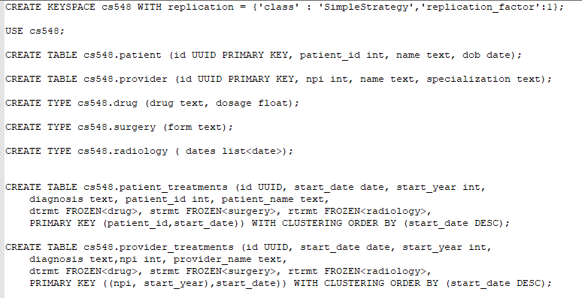

The main data model along with the keyspace.

Partitioning is used to store data across nodes, and clustering order will present the data in order before querying.

Unlike SQL, users have to add data to different tables since no foreign key design is used.

For this assignment the uuid is generated by uuid() function in Cassandra.

All data models, sample data and test queries are in the same script named Script.cql.